EXPERIMENT 4
IMPLEMENTION OF HILL CIPHER

Aim:
To implement the Hill Cipher substitution technique using Python.

Algorithm:
• Read the plaintext.
• Read the key matrix.
• Convert letters into numbers.
• Perform matrix multiplication modulo 26.
• Convert numbers back into letters.
• Display the encrypted text.

Code:
import numpy as np
key = np.array([[3, 3], [2, 5]])
plaintext = input("Enter Plain Text: ").upper().replace(" ", "")
if len(plaintext) % 2 != 0:
plaintext += "X"
encrypted = ""
for i in range(0, len(plaintext), 2):
pair = np.array([[ord(plaintext[i]) - 65],
[ord(plaintext[i + 1]) - 65]])
result = np.dot(key, pair) % 26
encrypted += chr(result[0][0] + 65)
encrypted += chr(result[1][0] + 65)
det = int(round(np.linalg.det(key)))
det = det % 26
for i in range(26):
if (det * i) % 26 == 1:
det_inv = i
break
adj = np.array([[key[1][1], -key[0][1]],
[-key[1][0], key[0][0]]])
inv_key = (det_inv * adj) % 26
decrypted = ""
for i in range(0, len(encrypted), 2):
pair = np.array([[ord(encrypted[i]) - 65],
[ord(encrypted[i + 1]) - 65]])
result = np.dot(inv_key, pair) % 26
decrypted += chr(int(result[0][0]) + 65)
decrypted += chr(int(result[1][0]) + 65)
print("Encrypted Text:", encrypted)
print("Decrypted Text:", decrypted)

Output:
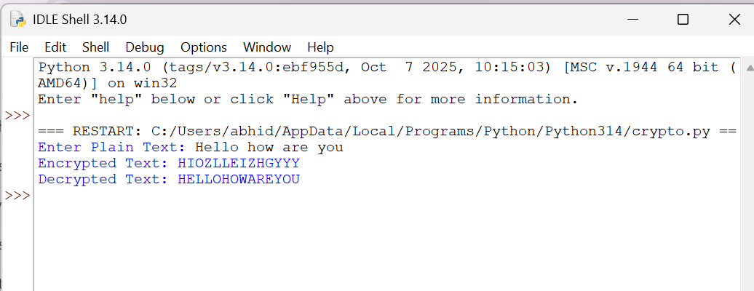
Result:
Thus, the Hill Cipher substitution technique was implemented successfully
using Python.

